How to add DogeChain to Metamask
The most reliable way to interact with the DogeChain is with Metamask. In order to add the DogeChain network, first click on the network selector and then to “Add Network”.
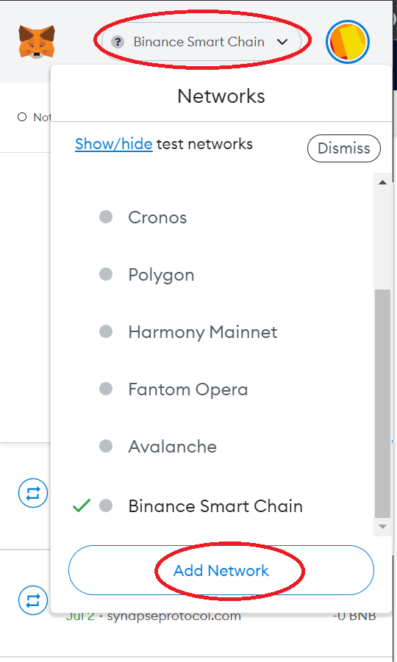

Enter the following information of the DogeChain to add it to Metamask.

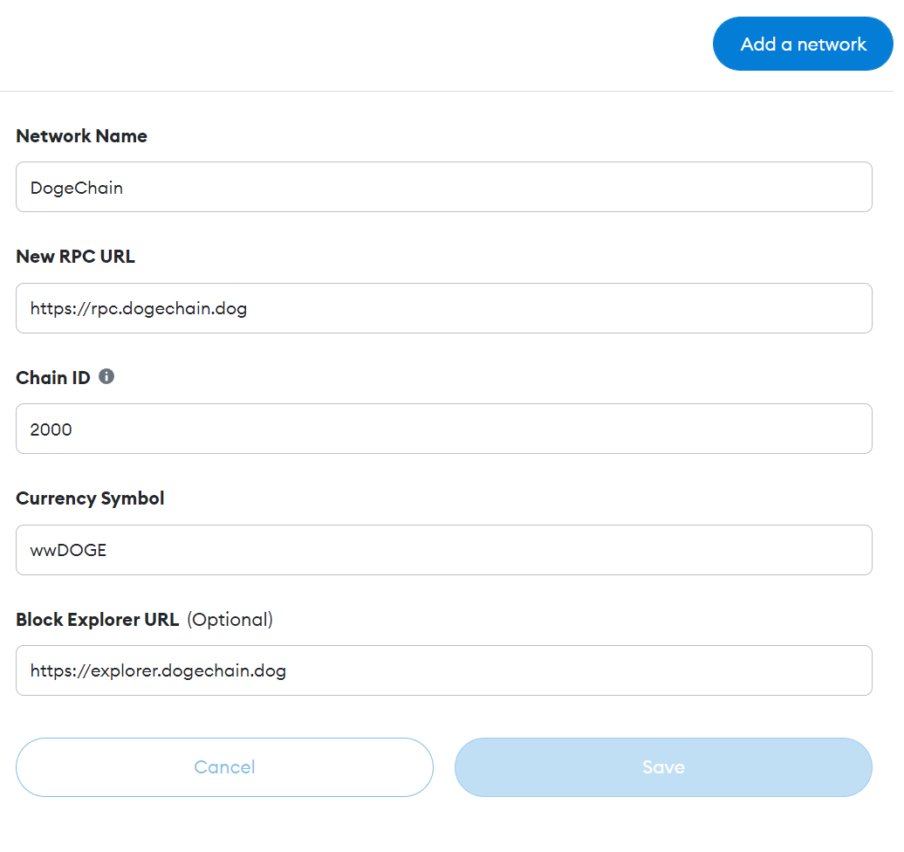
Now you are ready to interact with DogeChain.
The token used to pay gas fees is wwDOGE (which is wrapped wDOGE).

How to buy wwDOGE
You need to follow the following steps to purchase wwDOGE.
- Purchase DOGE tokens via a CEX or via SafePal.
It is important that you have your DOGE tokens on the Dogecoin network, all other networks (like BEP20, BEP2,…) are not supported.
Before purchasing DOGE tokens you need to add DOGE tokens in SafePal.
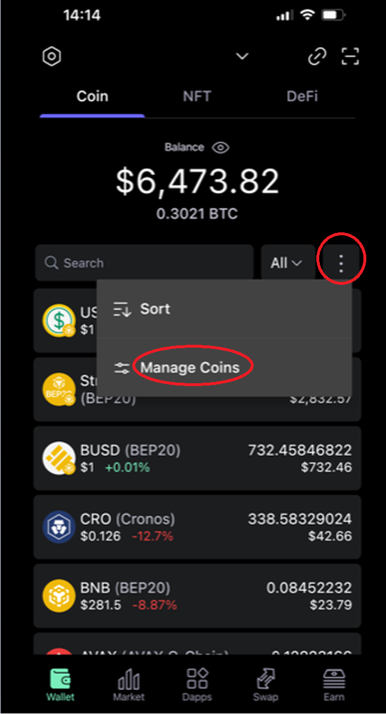
First click on the menu button and then on “Manage Coins”.
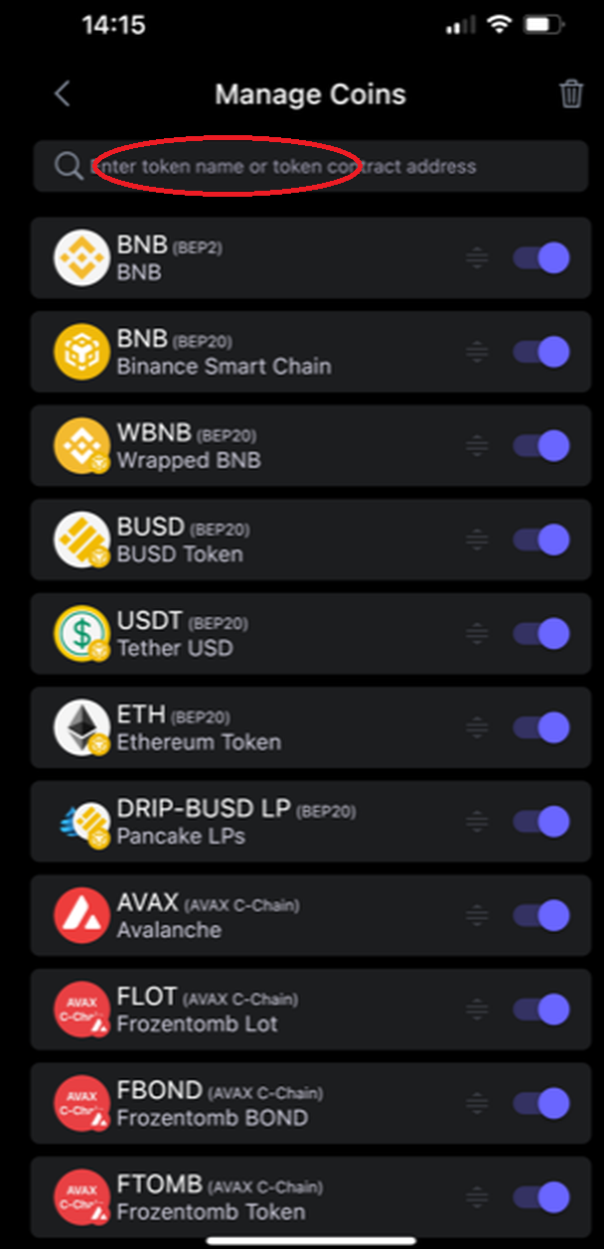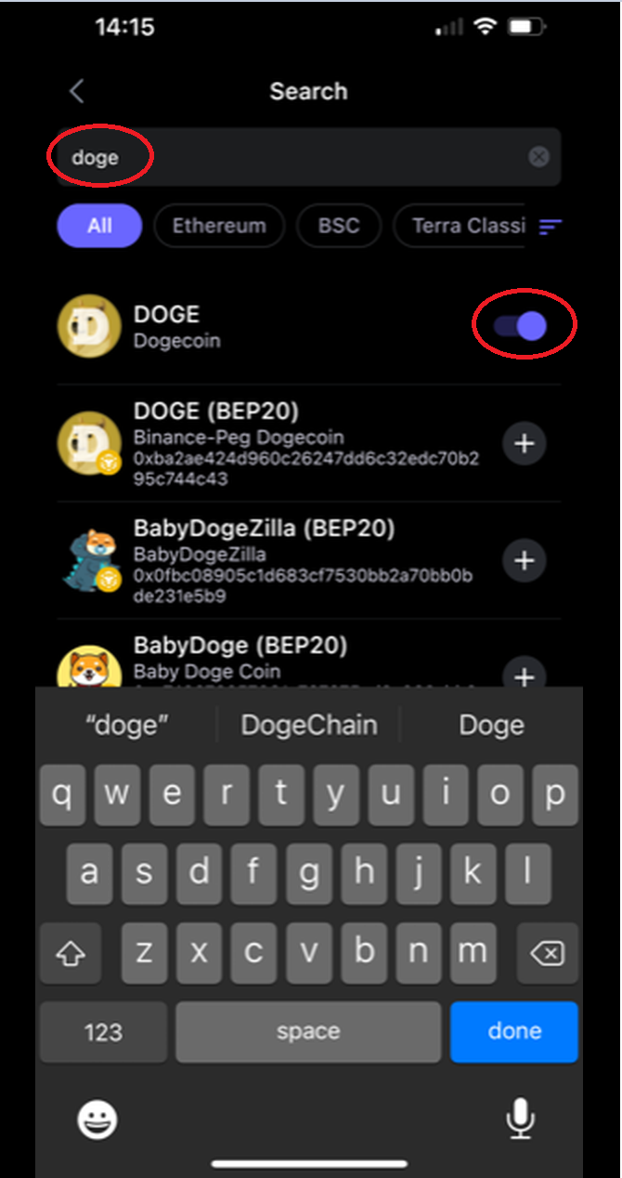
On the search field type DOGE, then activate the DOGE token.
Now you will see the token on your list of tokens, there you will find the DOGE address of your wallet.
- Transfer your purchased DOGE tokens from the CEX to your wallet.
This step is optional. Some CEXs do not support to transfer DOGE tokens directly to a bridge, therefore this step might be necessary.
We verified SafePal and Trustwallet to support DOGE tokens on the Dogecoin network.
- Go to the website of the DOGE token bridge.
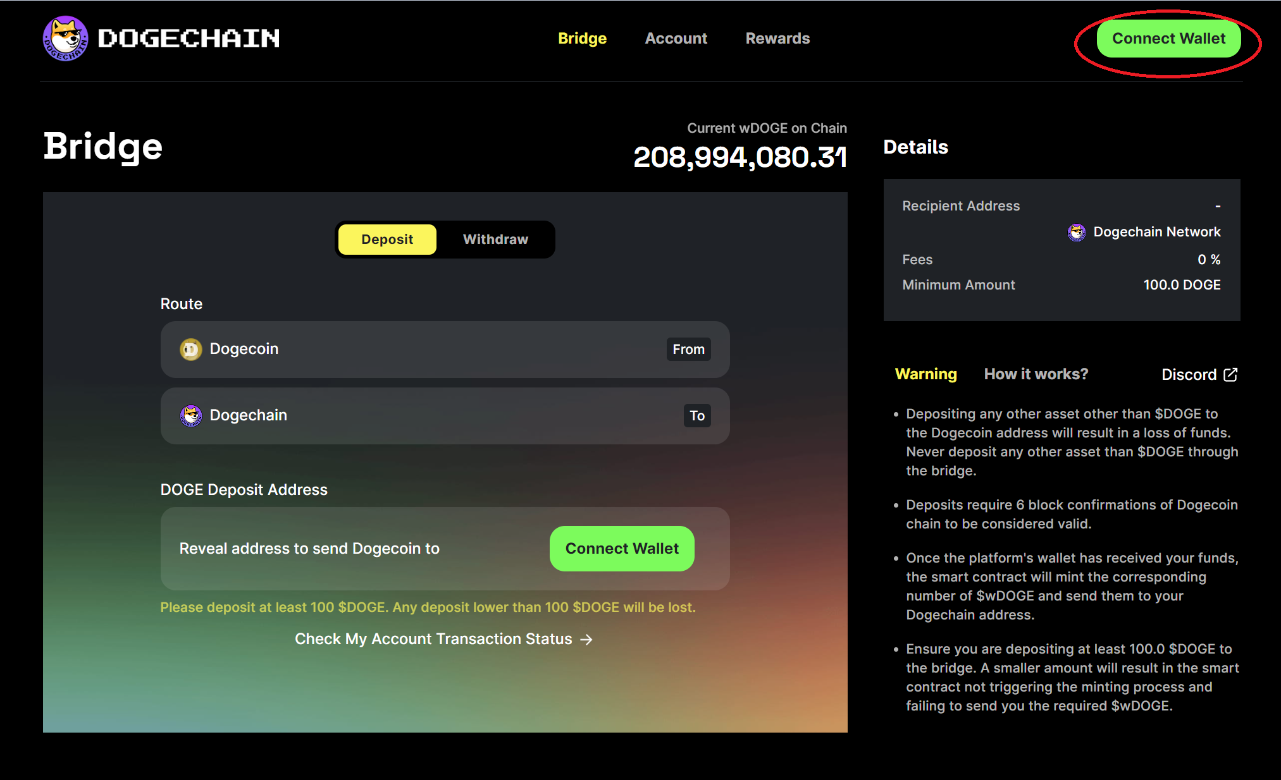
Open the site https://bridge.dogechain.dog/bridge and click on “Connect Wallet”. Connect your Metamask Wallet where you previously added DogeChain.
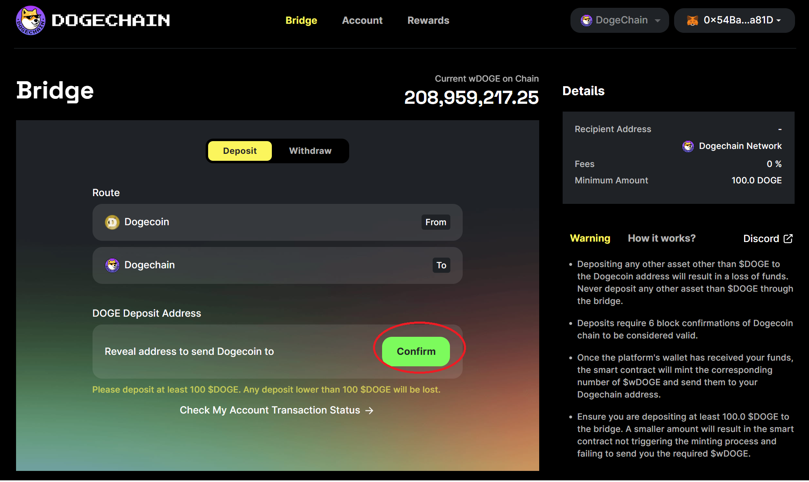
After connecting Metamask, press on “Confirm”, this will reveal the address where you have to transfer the DOGE tokens (which you purchased with SafePal or on a CEX) to.
Be aware that the transfer of the DOGE coins can take several minutes, at the time of writing this document the time for transferring DOGE coins to the bridge takes 7 minutes.
After transferring the DOGE coins to the bridge, the bridge will automatically convert the DOGE coins to wwDOGE, check on Metamask that you received your tokens.

How to buy Stratosphere on DogeChain
Use the following DEX to trade Stratosphere on the DogeChain:
https://dogeswap.org/#/swap
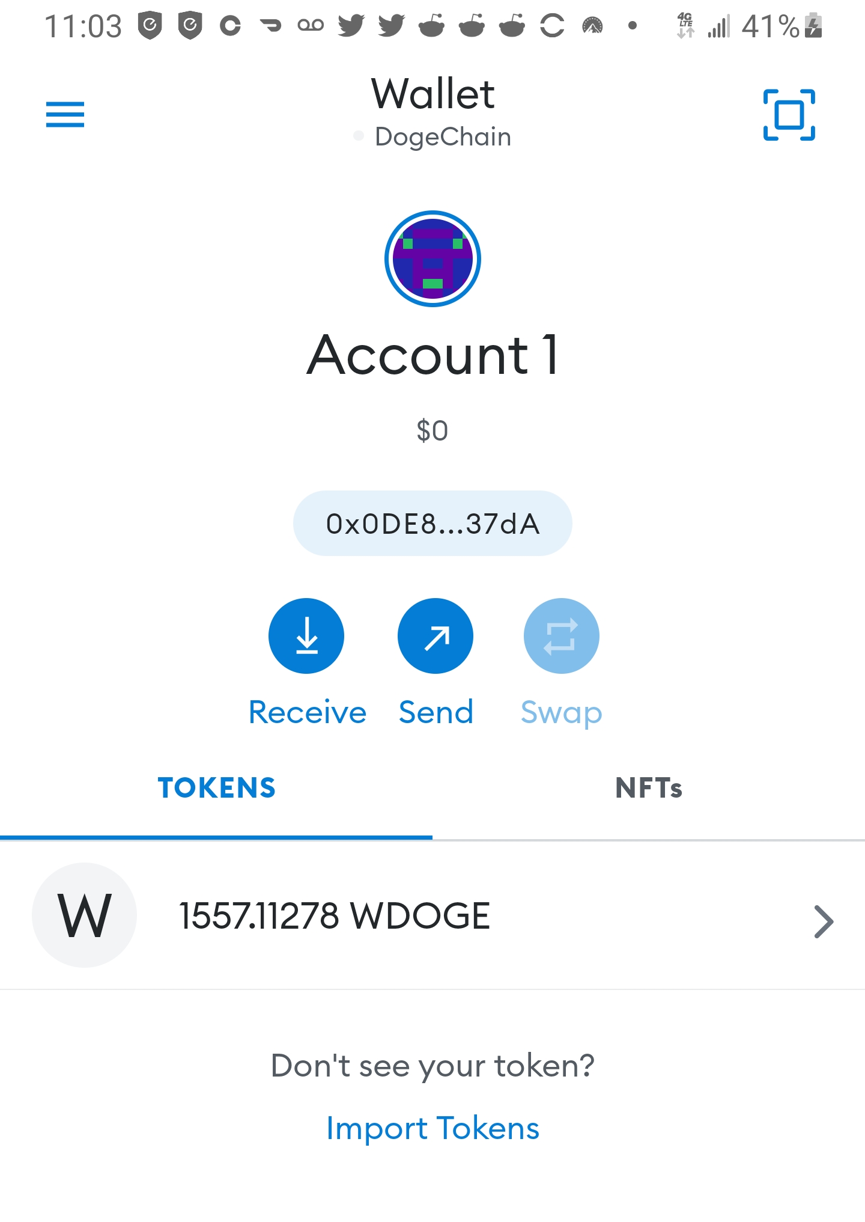
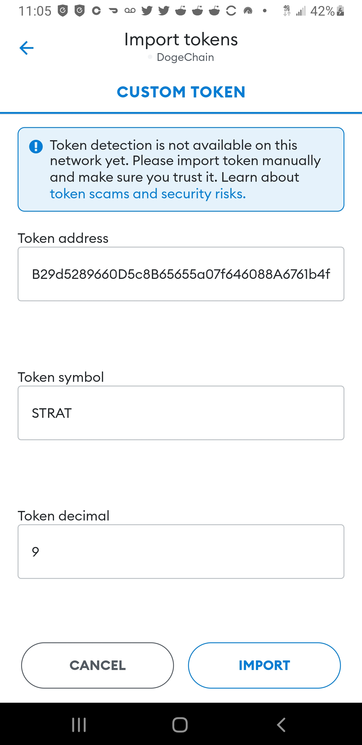
Step 1:
Open MetaMask wallet and
click on Import Tokens
Step 2:
In Token address field enter:
0x9B29d5289660D5c8B65655a07f646088A6761b4f
Change Token symbol from Stratosphere to STRAT
Click IMPORT button

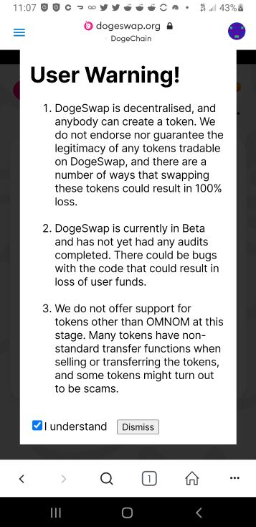
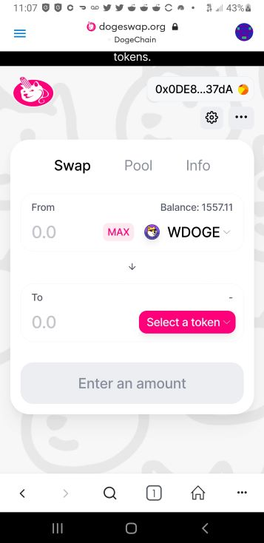
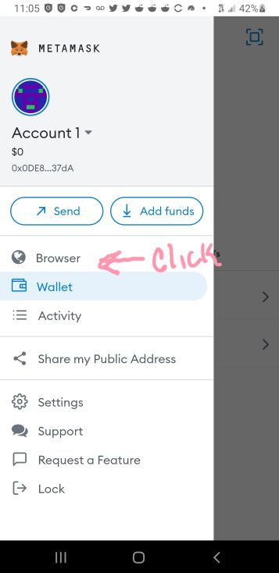
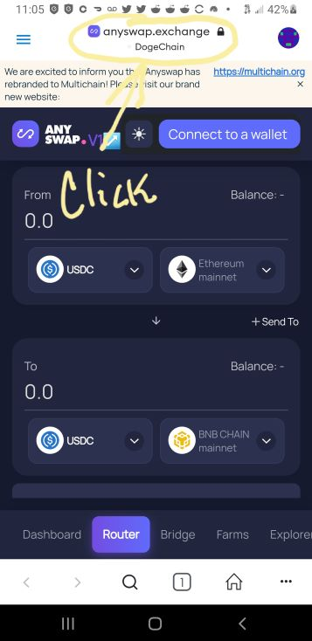
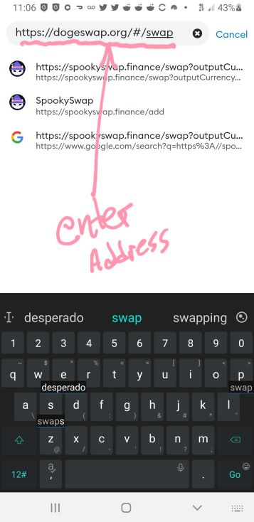
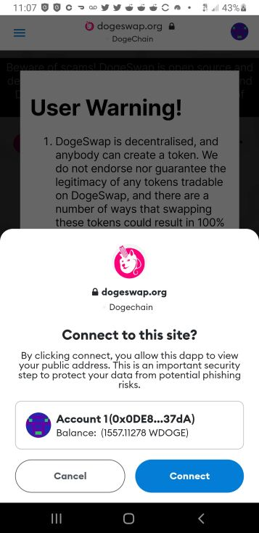

Step 4:
Click browser address field
Step 3:
Click three lines to access browser
Step 5:
Enter https://dogeswap.org/#/swap

Step 7:
Click checkbox & Dismiss button
Step 6:
Click Connect button
Step 8:
Click Select a token
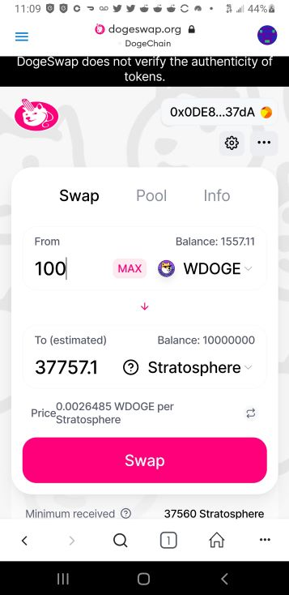

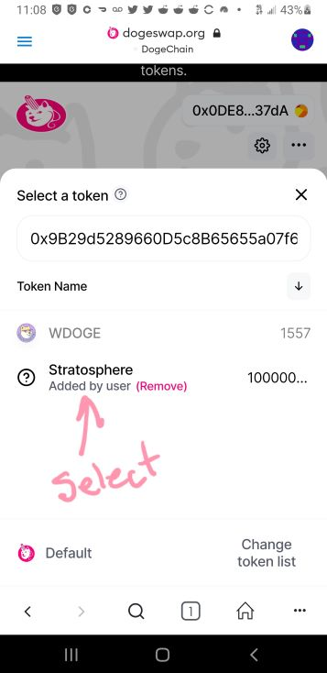
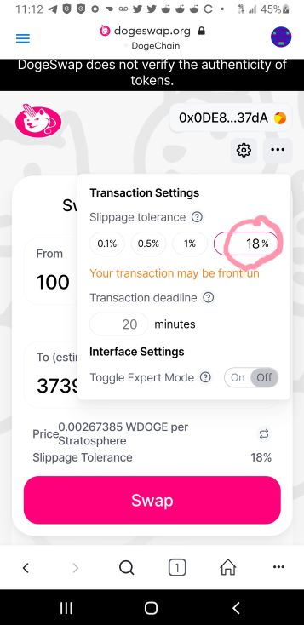
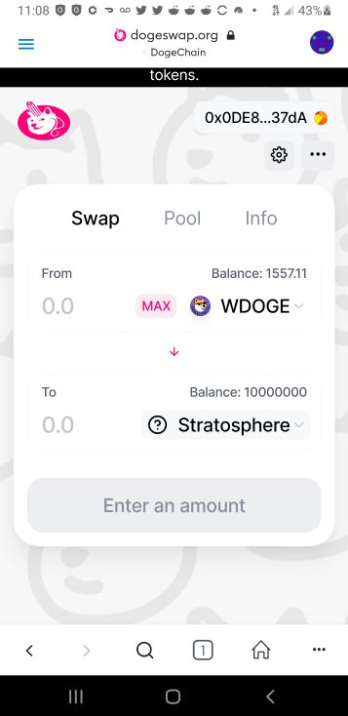
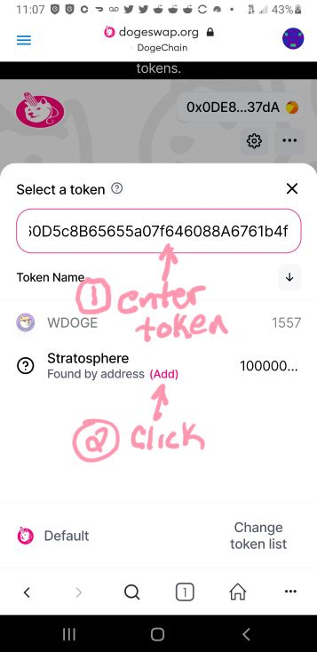

Step 11:
Your token is ready. Enter
The amount of wDoge to
swap for Stratosphere
Step 12:
Click the black gear to
Access Slippage and enter 18
Step 9:
Enter the Statosphere
contract Address & click (Add)
Step 10:
Select Stratosphere to show
Step 13:
Click Swap and confirm

